AGT1 - MODULE-3

Objectives
- Understand the difference between discrete and continuous data.
- Understand the mechanics of Surface Interpolation.
- Use the Spline Tool (Regularized).
- Use the Spline Tool (Tension).
Deliverables (To be submitted)
- Map showing use of each IDW tool. (Screenshot not Map Layout)
- Map showing use of both spline tools. (Screenshot not Map Layout)
- Map showing use of Kriging tool. (Screenshot not Map Layout)
- Map showing use of IDW tool with barrier. (Screenshot not Map Layout)
- Map showing use of spline with barrier tool. (Screenshot not Map Layout)

Lab Settings
Use Data in folder: AGT1-Data/Module3

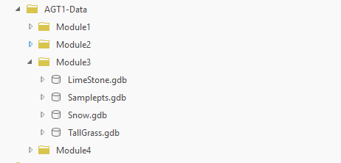

Scenario
In plain terms, "interpolation" is simply making a highly educated guess about missing information by looking at the information you already have.
Here is the easiest way to think about it: Imagine you are climbing a mountain.
- At the bottom, your thermometer says it is 20°C.
- At the top, your thermometer says it is 10°C.
- You didn't check the temperature exactly halfway up, but if someone asked you to guess what it was, what would you say?
You would probably guess 15°C.
You just interpolated. You used two known data points (top and bottom) to mathematically guess the missing data point in the middle.
The temperature example above is a straight line between two points. In GIS, you aren't just guessing in a straight line; you are guessing across an entire landscape in every direction. It’s called surface interpolation.
What is Surface Interpolation?
Imagine you stick a bunch of tent poles of different heights into the ground. Now, imagine throwing a giant, stretchy rubber sheet over the top of them. The sheet stretches and bends to touch the top of every single pole, filling in all the empty air between them.
In GIS, the "tent poles" are the scattered elevation points you actually measured in the field. The "rubber sheet" is the continuous terrain surface the computer generates to guess what the ground looks like everywhere else.
This mathematical magic of "filling in the blanks" between your known points is called Surface Interpolation.
In this exercise we shall explore different interpolation methods.

IDW
Imagine you want to guess the temperature in your backyard, but you only have thermometers at your neighbor's houses.
Inverse Distance Weighting (IDW) is basically a "weighted guessing" game. It works on one simple rule: the closer a neighbor is, the more you trust their number.
- If your next-door neighbor says it’s 30°C, that carries a lot of weight.
- If a neighbor three streets away says it’s 20°C, you still listen to them, but you don't trust them as much because they are further away.
To get your final answer, you take all those nearby numbers, give the "close" ones a big vote and the "far" ones a tiny vote, and find the average. It’s a great way to fill in the blanks on a map, making sure the areas between your known points look smooth and logical.
Goal: Use IDW tool.
Scenario: We know the elevation of a sample of points in our study area. We need to use it to generate an elevation raster for the entire area.

Load SamplePoints and StudyArea:

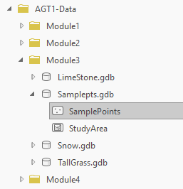

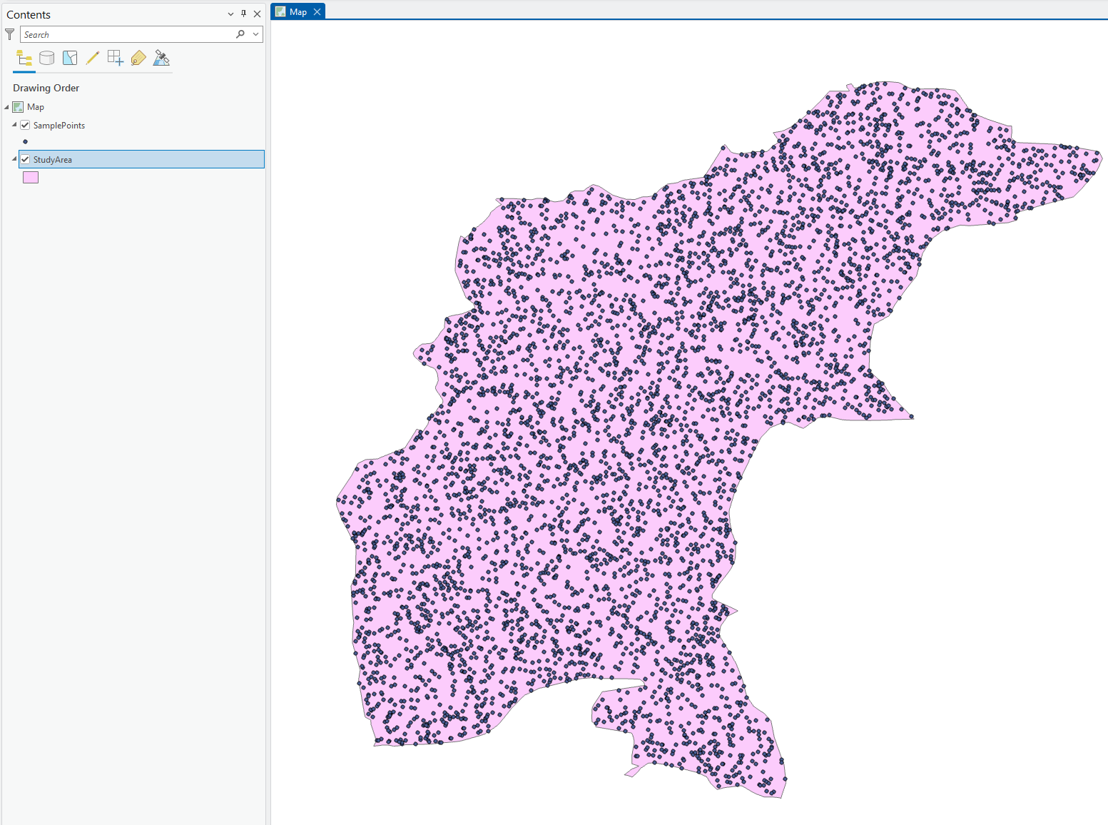

Open IDW Tool (Spatial Analyst):
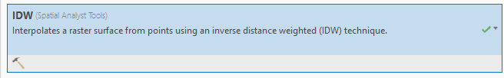
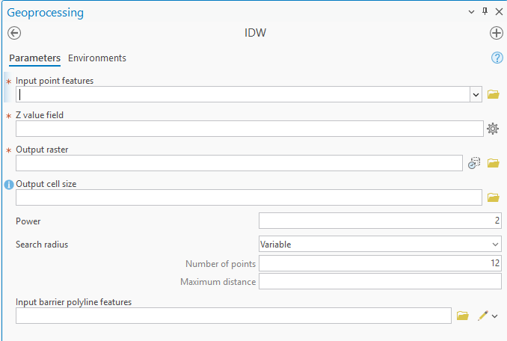

Required Inputs
- Input point features: These are your "known" data points—the locations where you already have measurements (like weather stations or soil samples).
- Z value field: This is the specific column in your data that contains the number you want to map (e.g., elevation, temperature, or pollution levels).
- Output raster: The name and location where your new, smooth map will be saved.

Key Controls
- Output cell size: This determines the resolution. A smaller number creates a finer, high-quality map with more detail, while a larger number creates a pixelated, blocky map.
- Power: This controls the "drop-off" of influence.
  - High Power (e.g., 3 or 4): Only very close points matter. Your map will look more "peaked" or spotted.
  - Low Power (e.g., 1): Faraway points get a bigger say. Your map will look smoother and more averaged out.
- Search radius: This tells the tool how far to look for neighbors.
  - Variable: It will keep looking until it finds a specific number of neighbors (default is 12).
  - Fixed: It only looks within a specific distance (e.g., 5km), no matter how many points are there.

Advanced
- Input barrier polyline features: Think of this as a "wall" (like a cliff or a river). If a point is on the other side of this line, the tool will ignore it, preventing data from "bleeding" across physical boundaries where it shouldn't.

Configure it as follows:
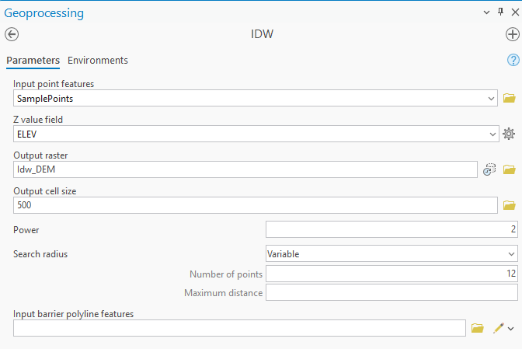
Before Processing we must set a Mask in the tool’s environment:
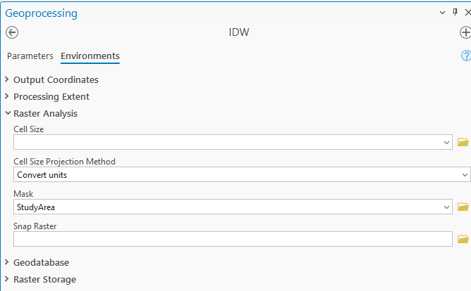

A Mask is essentially a "cookie cutter" for your map.
While the parameters tell the tool how to calculate values, the Mask setting in tells it where to stop. It prevents the tool from creating a giant rectangle of data, instead "clipping" the output to the exact shape of your study area.
This is necessary to:
- Keep things tidy: It removes messy data "bleeding" outside your specific borders.
- Save space: It ensures areas outside your boundary are marked as "NoData" rather than being filled with useless estimates.
- Match layers: It makes sure your results align perfectly with other map layers, like city or forest boundaries.

Hit Run:
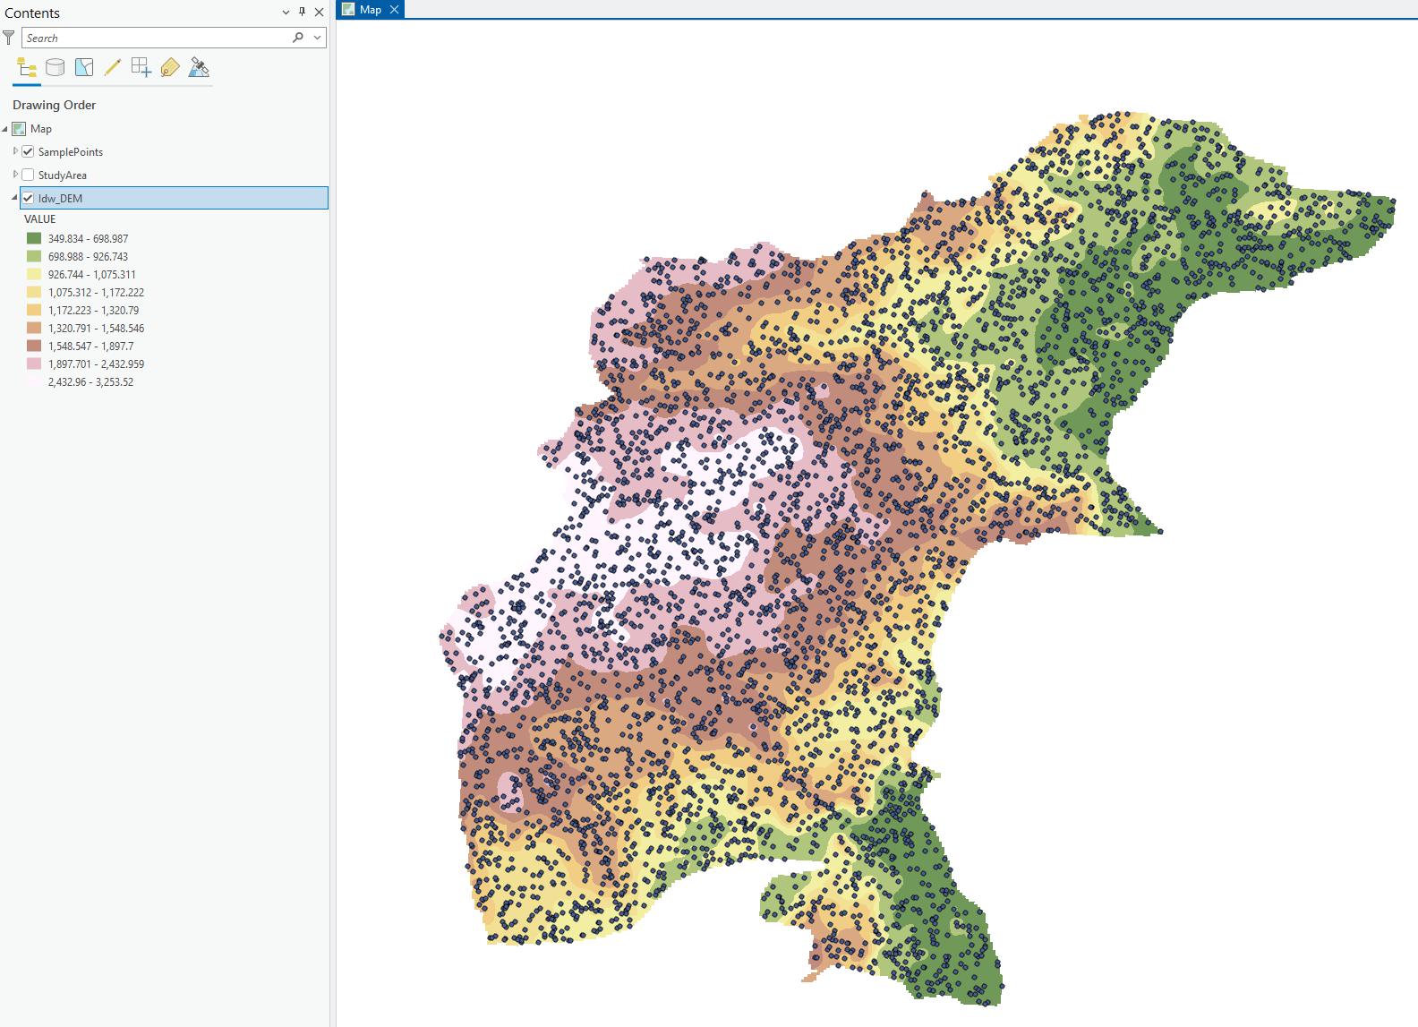

Spline Tool
The Spline tool is a deterministic interpolation method that fits a flexible, mathematical surface through your data points, much like a thin sheet of rubber being pulled to touch every point.
Unlike IDW, which can look "bumpy," Spline is designed to create the smoothest possible surface with continuous curvature. ArcGIS offers two primary versions:
- Regularized: This version results in a smooth, gradually changing surface. It allows the values of the output surface to potentially exceed the range of the input data, which is useful for creating gentle terrain or identifying subtle trends.
- Tension: This version constrains the surface more tightly to the data points, acting like a stiffer material. The resulting surface is flatter and the values are generally kept closer to the input range, making it ideal for data that shouldn't have extreme peaks or valleys.

Goal: Use Spline tool.
Scenario: We know the elevation of a sample of points in our study area. We need to use it to generate an elevation raster for the entire area.

Load SamplePoints and StudyArea:
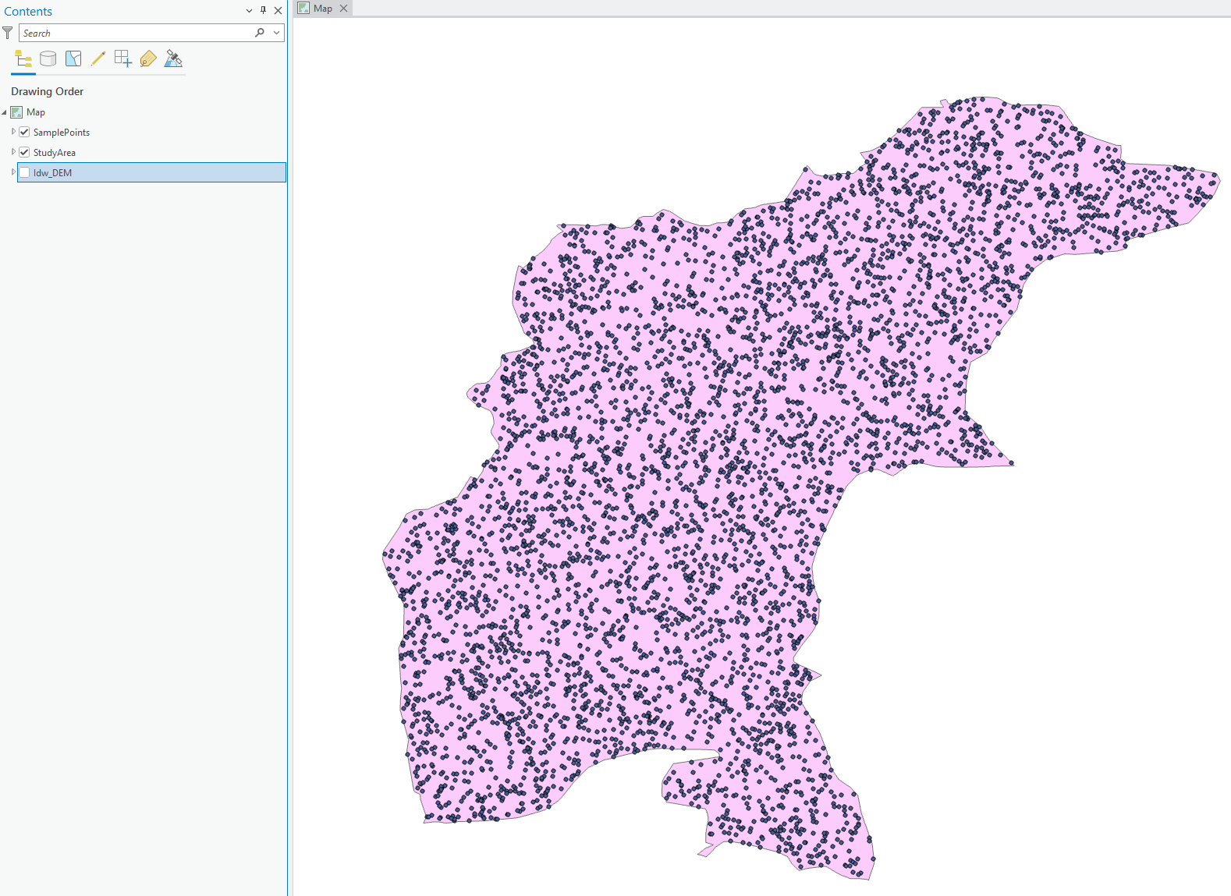

Open Spline Tool:
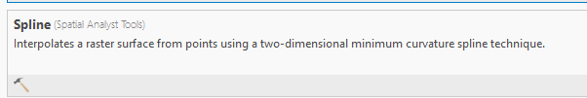
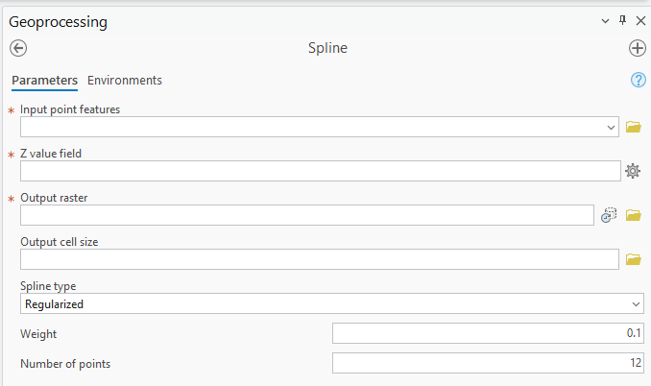

- Input point features: These are the measured locations you are using to build the surface.
- Z value field: The specific attribute being interpolated (e.g., elevation or rainfall).
- Output raster: Where the final smooth surface will be saved.
- Output cell size: Determines the resolution of the final map (smaller numbers mean higher detail).

- Spline type:
  - Regularized: Creates a very smooth, rounded surface. It is best for things like elevation where you want a natural, flowing look.
  - Tension: Makes the surface "stiffer." It keeps the predicted values closer to the actual data points and prevents the surface from overshooting or creating wild curves.
- Weight: This defines the influence of the chosen spline type.
  - For Regularized, a higher weight creates a smoother surface.
  - For Tension, a higher weight makes the surface more rigid and flat.
- Number of points: This specifies how many nearby points the tool uses to calculate the shape of the curve for each specific area. Using more points generally leads to a smoother overall result but requires more processing power.

Configure as follows:
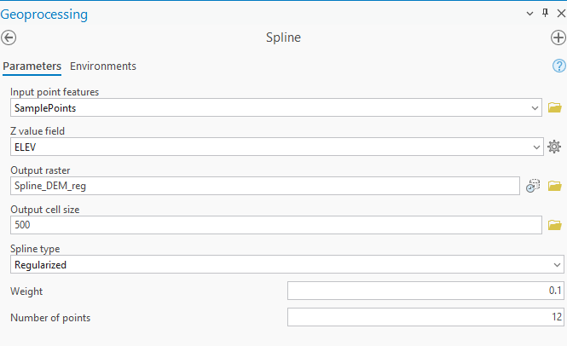
Make sure mask is set:
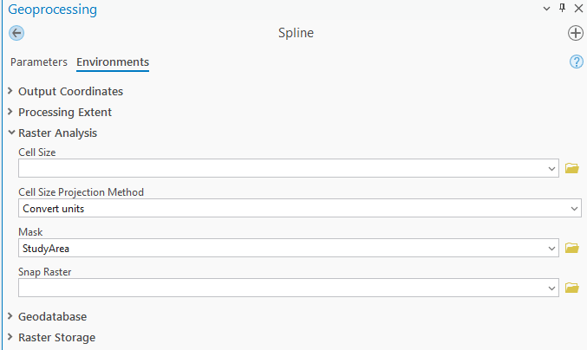
Hit Run:
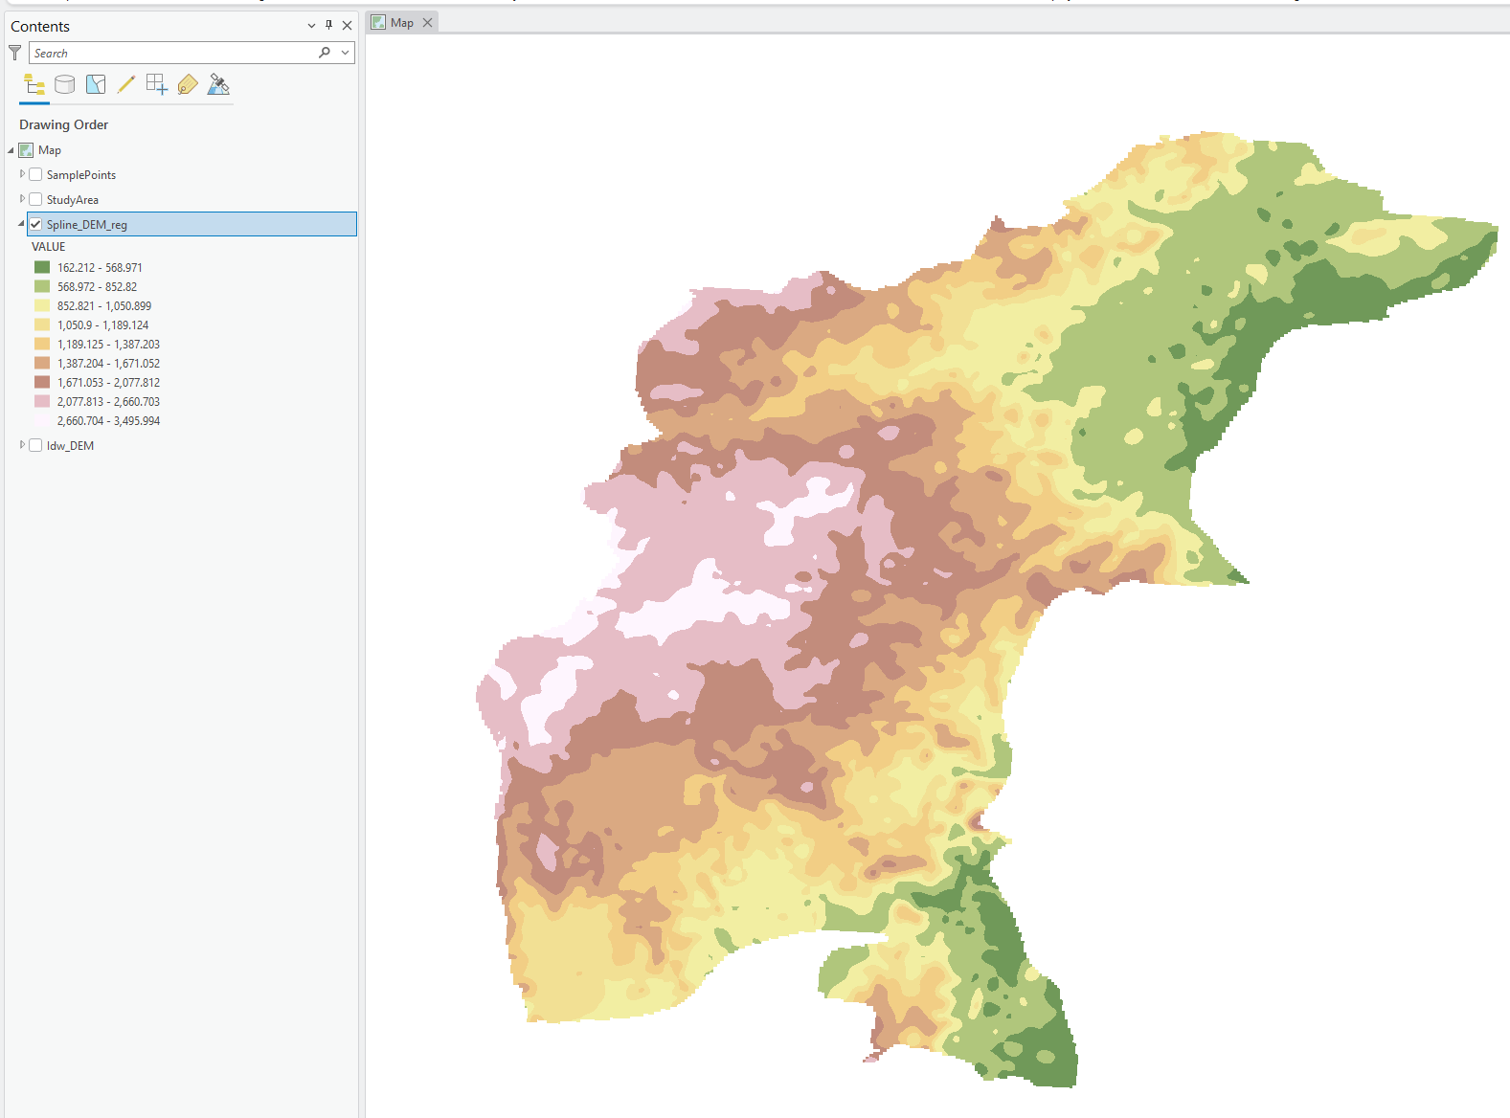

Run again for tension spline:
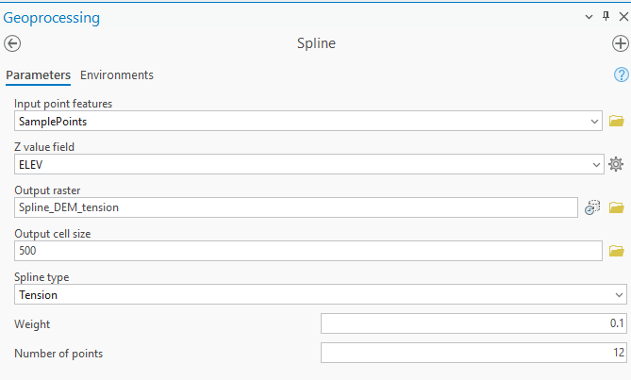
Hit Run:

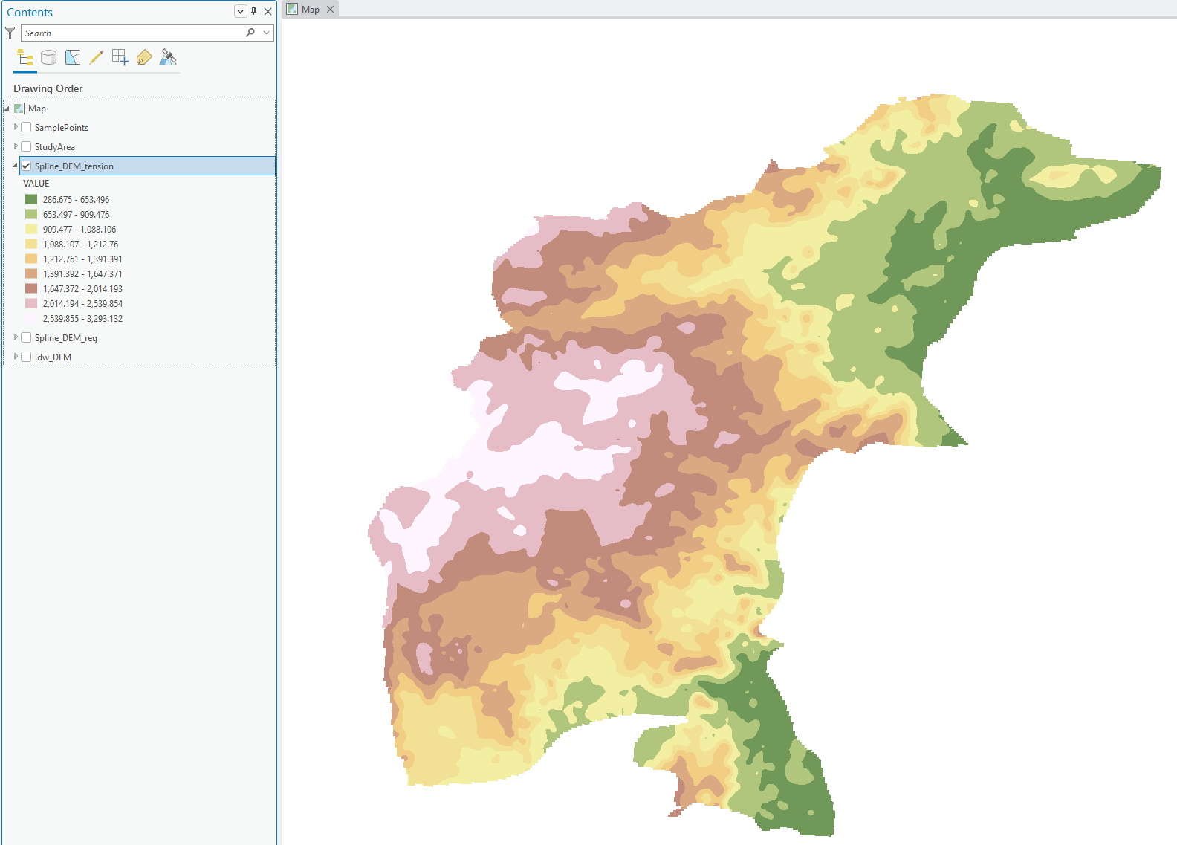

Natural Neighbour Tool
The Natural Neighbor tool is an interpolation method that offers a "best of both worlds" approach by being both smooth and highly localized.
It works by creating a Voronoi (Thiessen) polygon network around all your input points; to estimate a value for a new location, it temporarily inserts a "hidden" point at that spot and calculates how much area it "steals" from the surrounding polygons.
Because it only uses the immediate neighbors to make this calculation, it doesn't create the "bull's-eye" patterns often seen in IDW, nor does it overshoot the data range like Spline can.
It is especially effective for large datasets where you need a surface that looks natural and smooth but stays strictly within the boundaries of your highest and lowest measured values.

Goal: Use Natural Neighbor tool.
Scenario: We know the elevation of a sample of points in our study area. We need to use it to generate an elevation raster for the entire area.

Open Natural Neighbor tool:
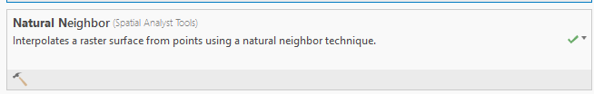
Configure as follows:
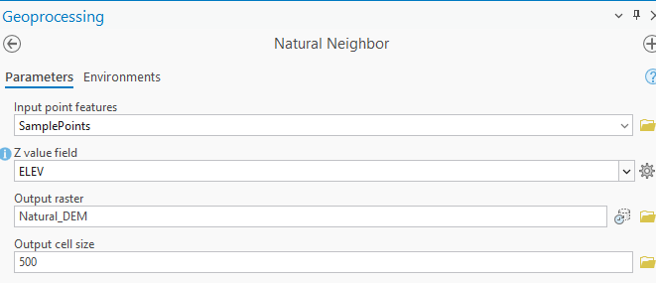
Hit Run:
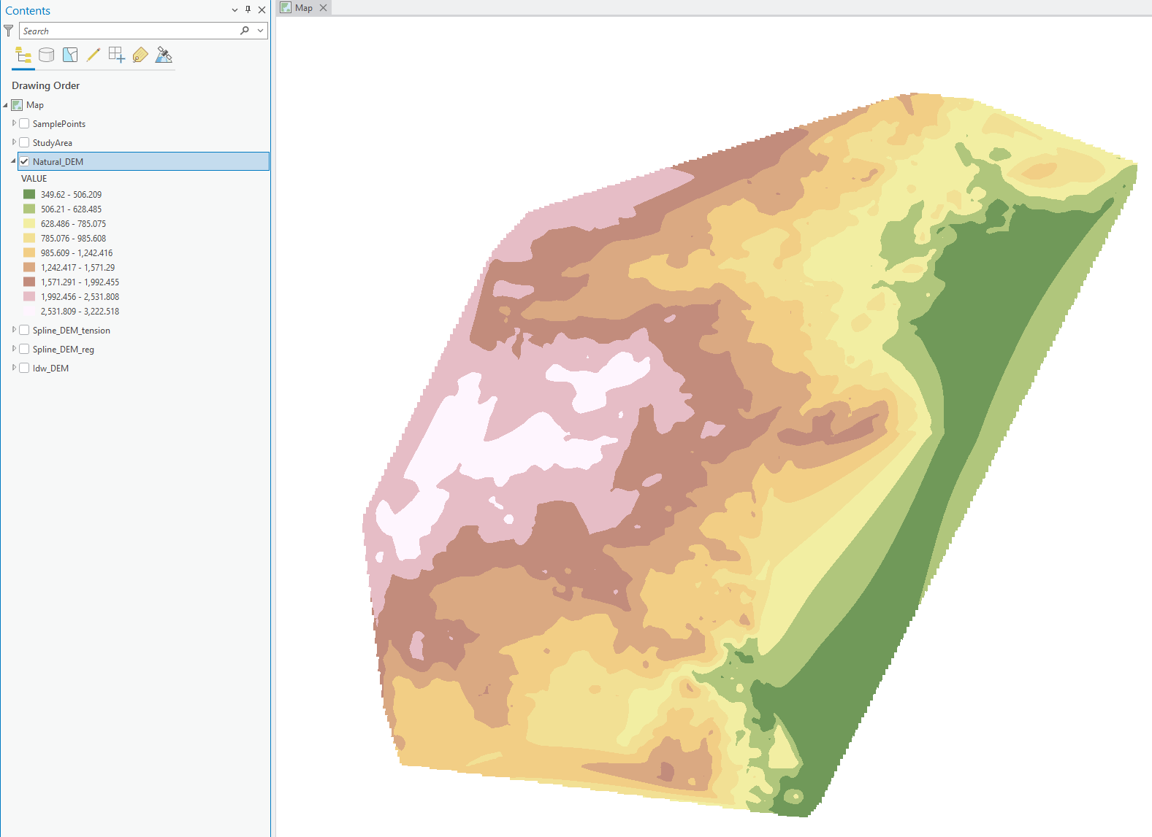

Krigging Tool
Kriging is a powerful geostatistical interpolation method that differs from IDW or Spline by utilizing the statistical relationships between measured points to predict unknown values.
Rather than just looking at distance, it uses a variogram to account for spatial correlation, the idea that the distance and orientation between points reflect a specific pattern in the landscape.
It provides not only an estimated surface but also a measure of certainty or prediction error, telling you how much you should trust the results in different areas.
This makes it the preferred tool for complex scientific modeling, such as mining, soil mapping, or environmental science, where understanding the reliability of the map is just as important as the map itself.

Goal: Use Krigging tool.
Scenario: We know the elevation of a sample of points in our study area. We need to use it to generate an elevation raster for the entire area.

Open Krigging Tool:
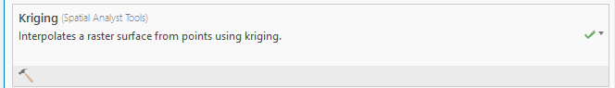
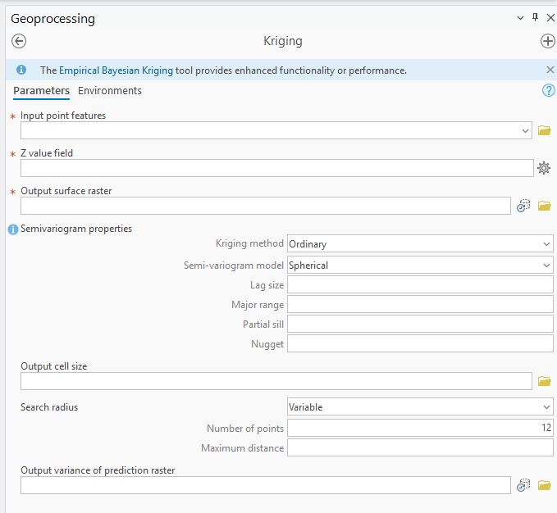
- Input point features: The known data points you are using to build the statistical model.
- Z value field: The specific measurement (e.g., soil pH or mineral density) you want to map.
- Output raster: The final estimated surface file.
- Output cell size: The resolution of the final map.

- Kriging Method:
  - Ordinary: Assumes there is a constant but unknown mean across the data; this is the most common version.
  - Universal: Assumes there is an underlying trend (like a steady slope) in the data that needs to be accounted for.
- Semivariogram Model: This is the "brain" of Kriging. It defines the mathematical curve (Circular, Spherical, Exponential, etc.) that best describes how the similarity between points drops off as distance increases.
- Search Radius:
  - Variable: Looks for a set number of points (default is 12) to calculate the value of a cell.
  - Fixed: Only looks within a specific distance, regardless of how many points are there.
- Output prediction error raster: A unique Kriging feature that creates a second map showing the "uncertainty" or standard error, highlighting where your data is most and least reliable.

Configure as follows:
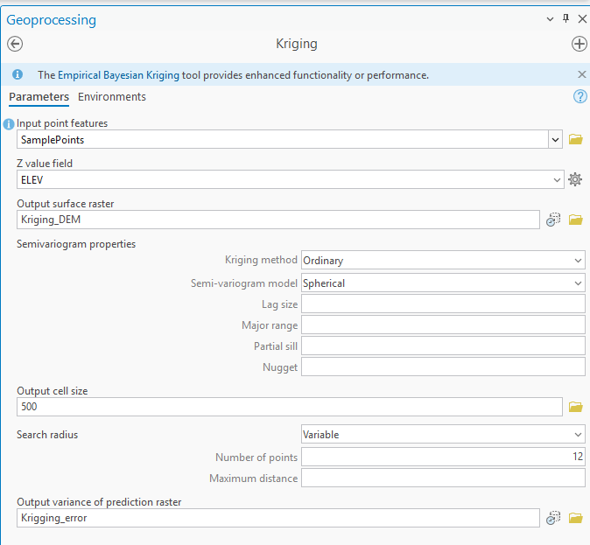
Hit Run:
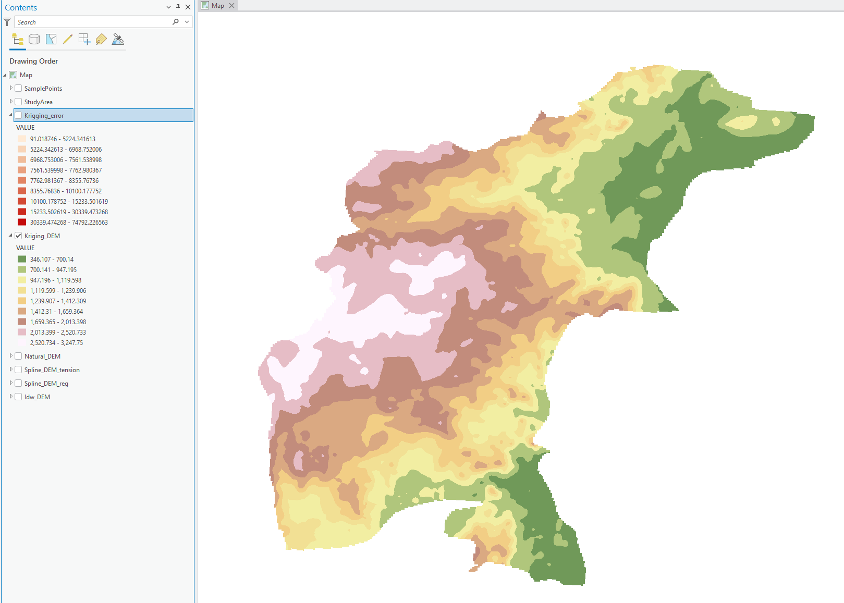

The variance raster looks like:
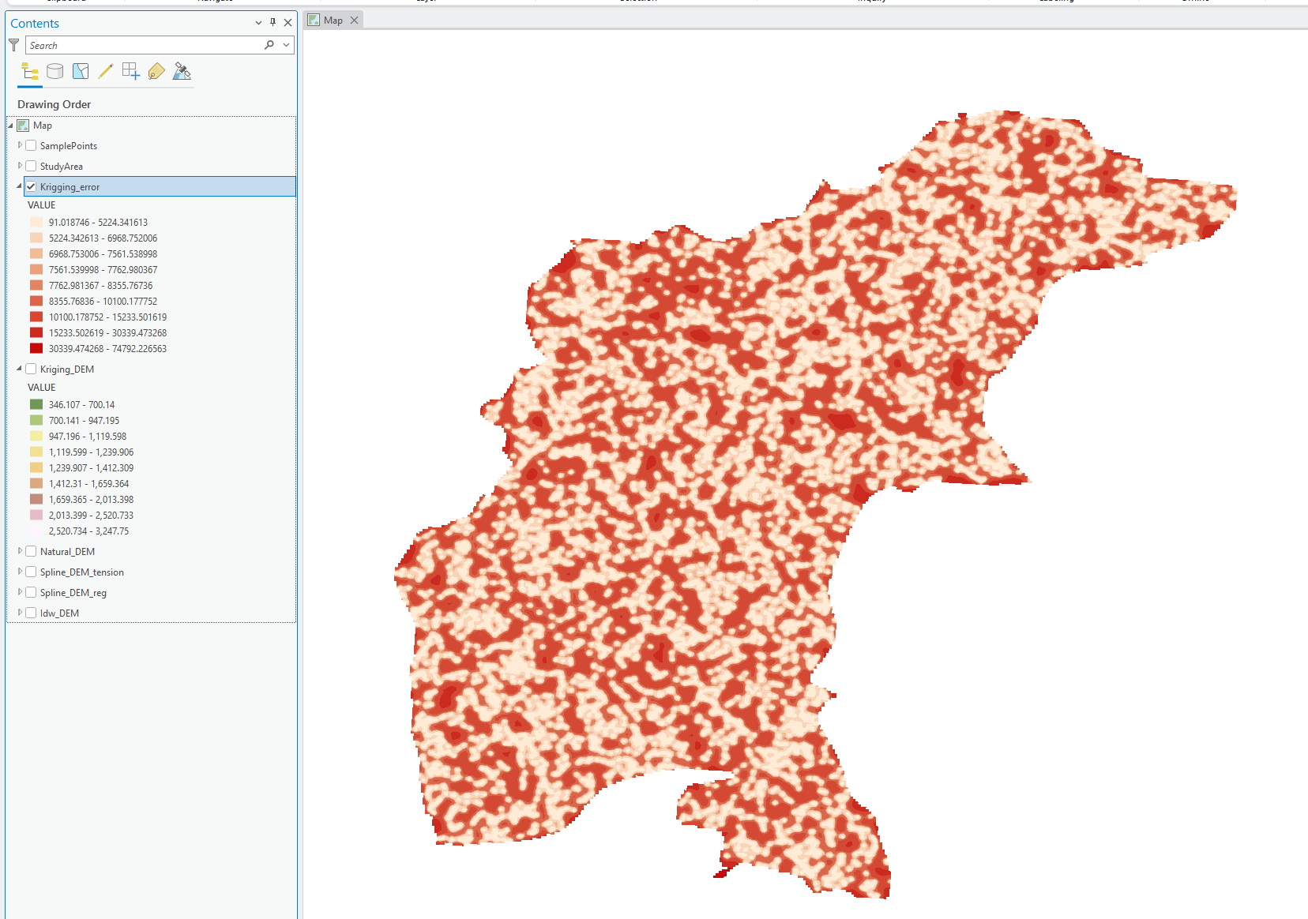
Notice that it’s the least at the points and then increases as we go further.

When to use What?
Choosing the right interpolation method is about matching the mathematical "logic" of the tool to the real-world behavior of what you are mapping.

1. Know Your Boundaries (The "Z-Value" Rule)
- Use IDW if your data should never go above or below your measured points. For example, if you are mapping pollution levels, the concentration shouldn't magically become higher than your highest reading between two sensors.
- Use Spline if you know the real-world surface has peaks or valleys that your sensors might have missed. Because Spline uses curves, it can "overshoot" the measured points to create a smooth hill or depression.

2. Check Your Data Distribution
- Use IDW if you have many points that are close together but have wildly different values. Spline struggles with this and might create strange, unrealistic "waves" in the map.
- Use Kriging if your points are sparse or poorly distributed. Kriging is great at handling complex terrain where things change abruptly because it looks at the statistical probability of the data rather than just simple distance.

3. Consider the "Look" and "Certainty"
Method | Best For... | Visual Result
IDW | Simple, quick estimates. | Can look "bumpy" (bull's-eyes).
Spline | Gently varying surfaces (like elevation). | Very smooth and artistic.
Natural Neighbor | Large datasets with varied density. | Natural, localized smoothing.
Kriging | Scientific analysis where accuracy matters. | Statistical and provides "error" maps.

You shouldn't just pick one and hope for the best. The best workflow is to try multiple methods and compare them against your own knowledge of the area. If a Spline map shows a massive hill where you know the ground is flat, you'll know to switch to IDW or Kriging.

Interpolation With Barrier Tool
The Interpolation with Barriers tool is a specialized version of interpolation method that accounts for physical or logical interruptions in a landscape.
While standard interpolation assumes that values transition smoothly across all space, this tool uses barrier polyline features to prevent data from "bleeding" across boundaries where it shouldn't, such as cliffs, rivers, or fault lines.
When the tool encounters a barrier, it essentially "breaks" the connection between points on opposite sides, ensuring that the estimated value for a cell is only influenced by neighbors that have a direct, unobstructed path to it.
This is essential for creating realistic maps in complex environments where a sudden physical change would naturally stop the flow of a variable like water temperature or soil moisture.

Goal: Use IDW tool with a barrier.
Scenario: Think of an anticline like a giant, underground stone bridge or a curved roof. This shape is important because it can act as a natural "container" for oil, gas, or water.
In this task, you are looking at data from drill holes that hit the top of a limestone layer where oil was found. To see how this layer bends underground, you will use the IDW tool to turn those specific drill points into a smooth map.
You will run the tool two different ways to see the difference:
- Without a Barrier: A standard map where the data flows freely between all points.
- With a Barrier: A map that accounts for physical breaks (like a fault line) that would stop the rock layer from being continuous.

Load Drillhole and Study area:
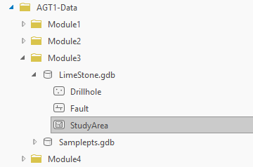
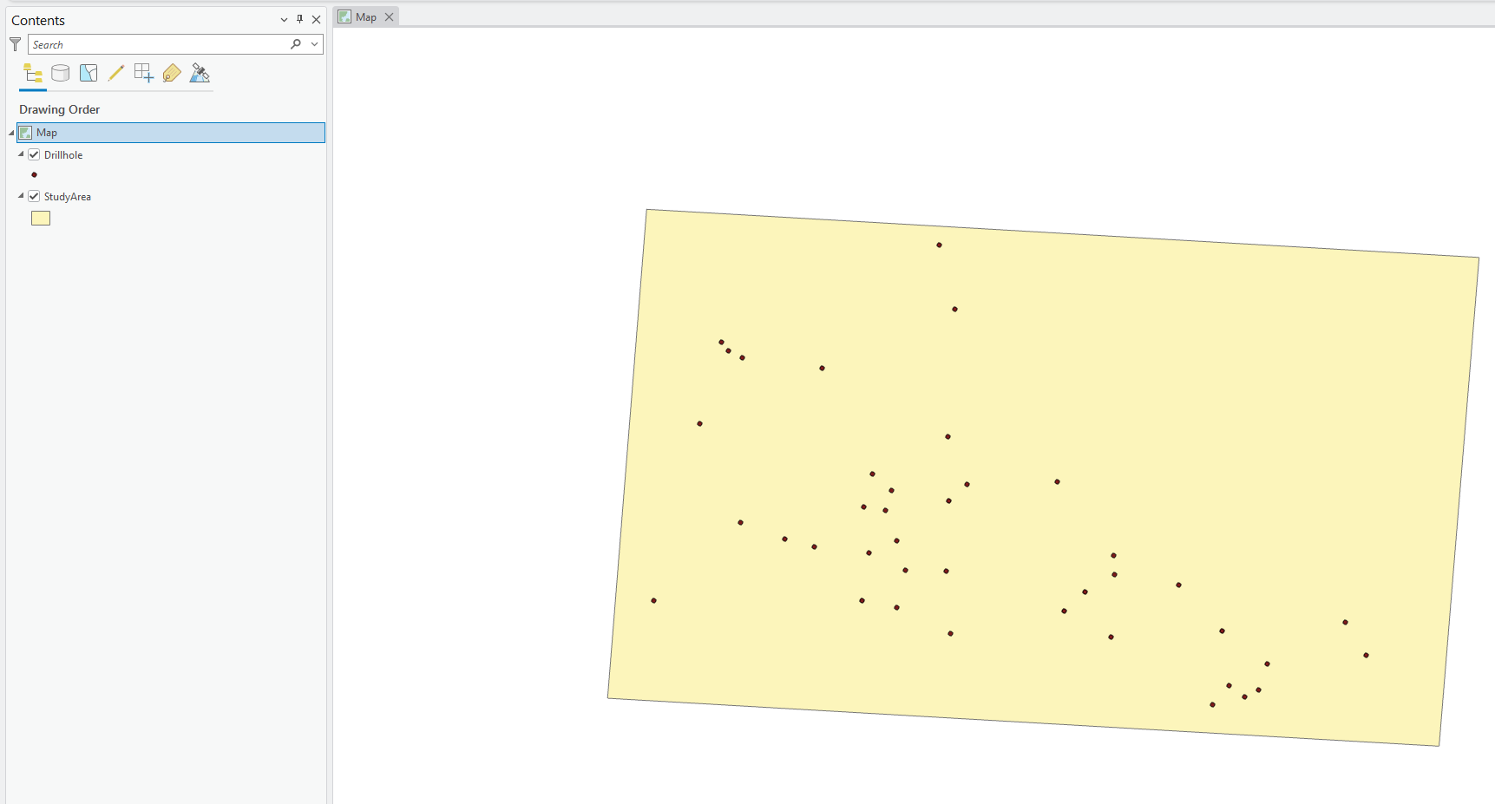

Let’s explore attributes:
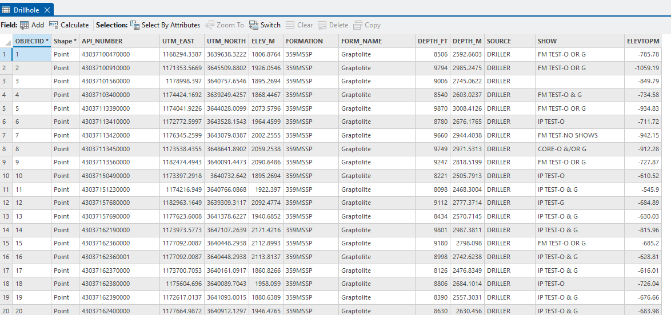
Don’t worry about the other fields, we only need to know that ELEVTOPM shows the depth till the limestone formation.

Open IDW Tool:
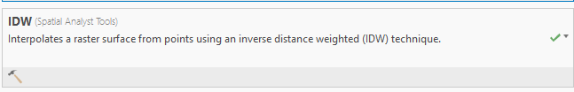
Configure as follows (without barrier):
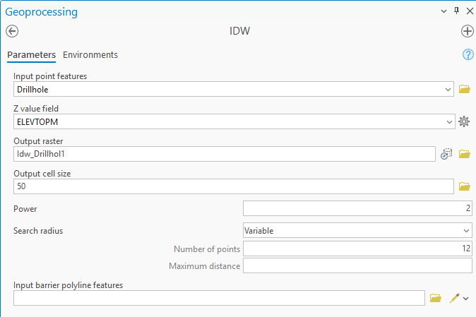
Ensure mask is set to study area:
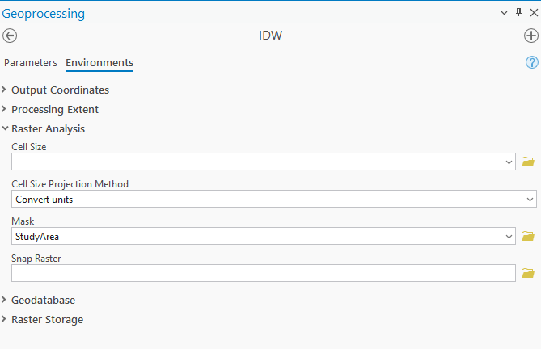
Hit run:
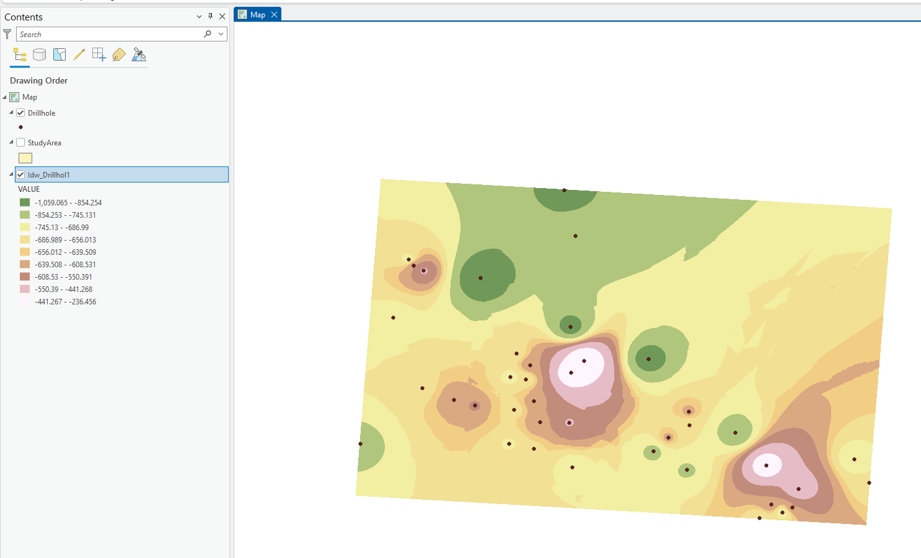
Now load Fault Lines:
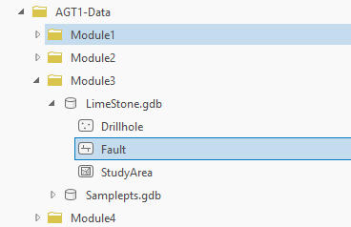
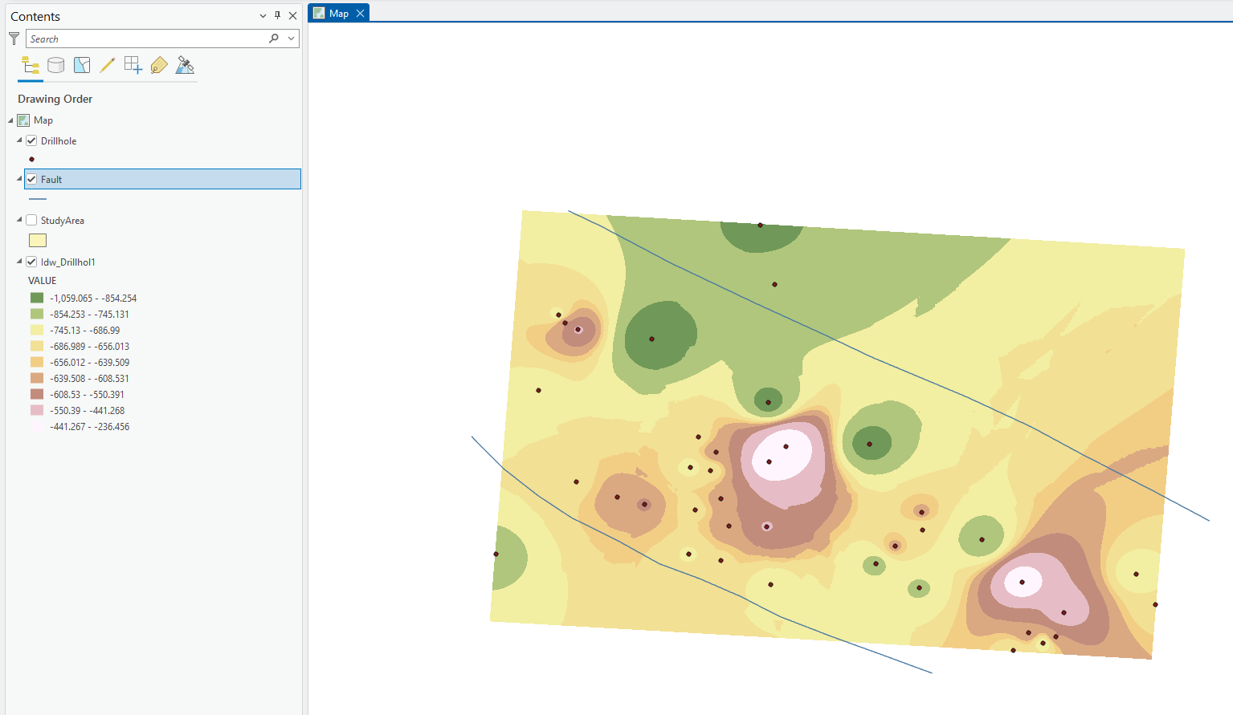

Re-run the IDW tool but this time set Fault as the interpolation barrier:
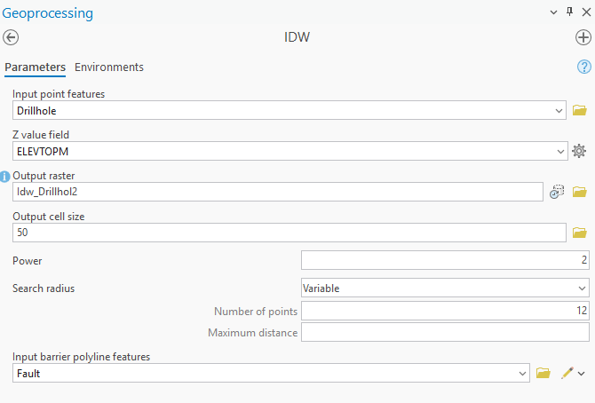
Hit Run:
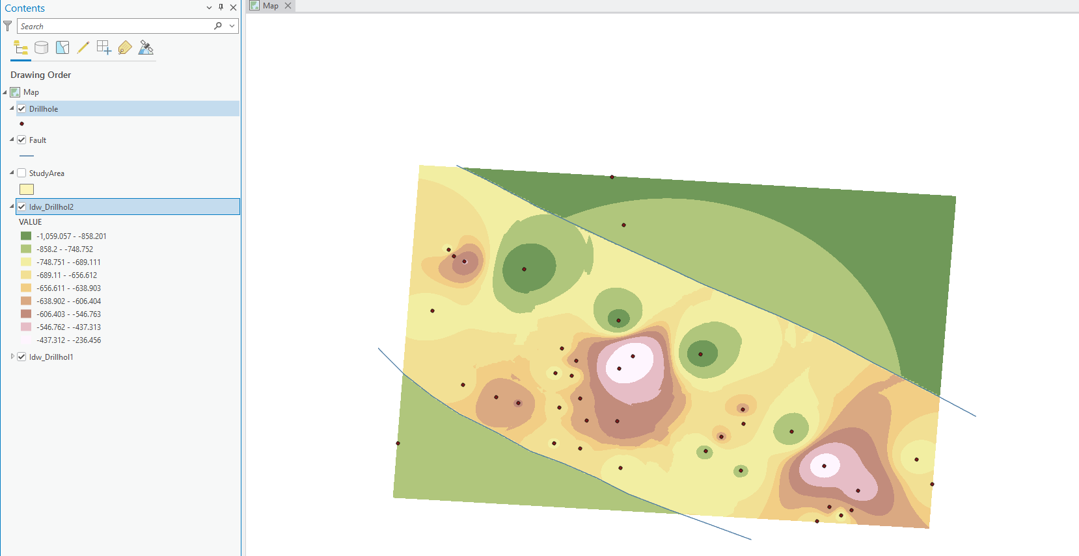
You can notice a clear difference due to the fault line.
We can also use spline with barrier:
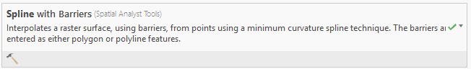
Configure as follows:
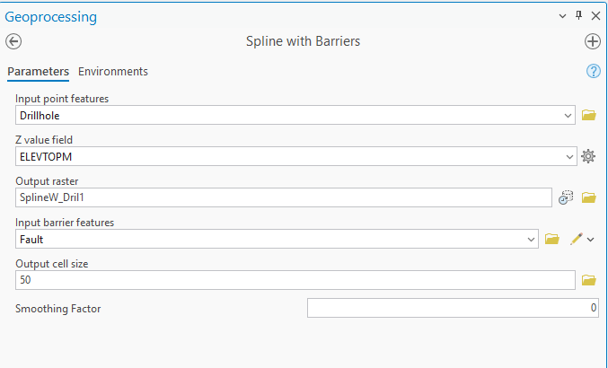
Ensure Mask is set:

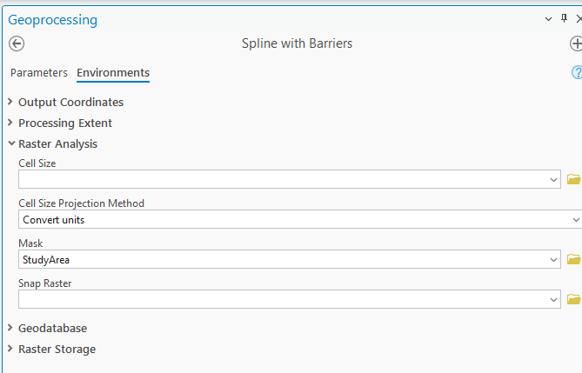

Hit run:
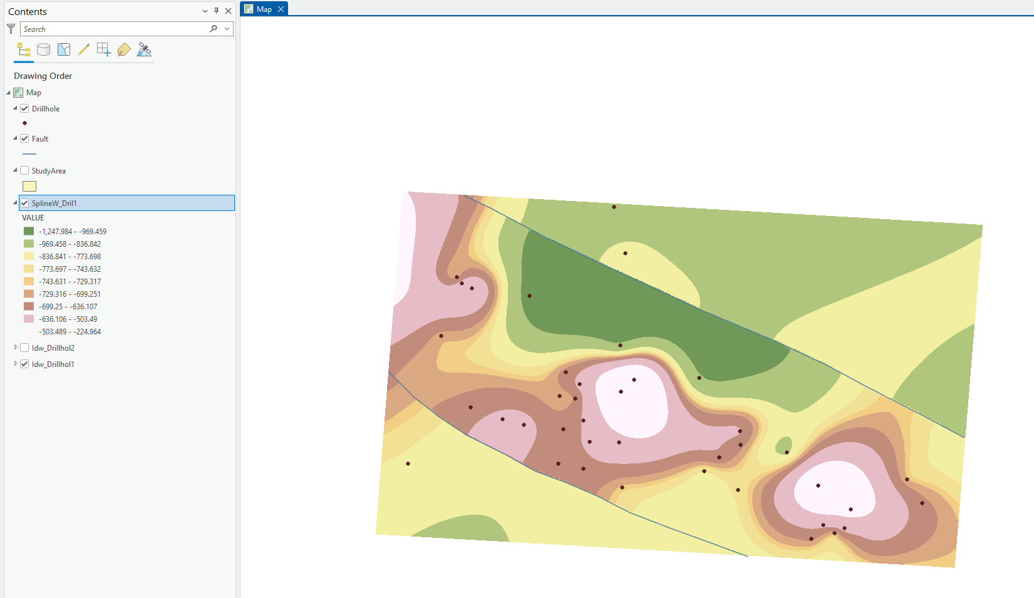

Deliverables (To be submitted)
- Map showing use of each IDW tool. (Screenshot not Map Layout)
- Map showing use of both spline tools. (Screenshot not Map Layout)
- Map showing use of Kriging tool. (Screenshot not Map Layout)
- Map showing use of IDW tool with barrier. (Screenshot not Map Layout)
- Map showing use of spline with barrier tool. (Screenshot not Map Layout)

